BRING THE MAGIC OF JAPAN INTO YOUR HOME BY BECOMING A

HOST FAMILY

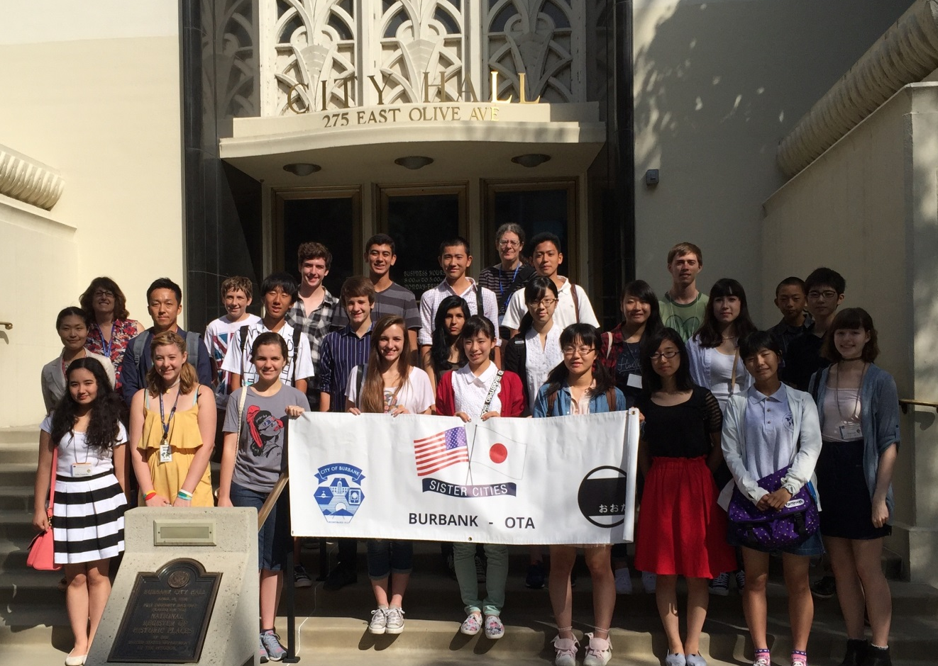

The Burbank Sister City Committee (BSCC) is now accepting applications to host visiting exchange students from our sister city in Ota, Japan. Our Japanese guests will be visiting Burbank for two weeks from in July or August 2017, and you are invited to share your home with them.

To qualify as a Host Family you must agree to all of the following conditions:

Be a Burbank resident

Have a suitable household that provides privacy and comfort for the visiting student.

Have a safe household equipped with fire alarms/smoke detectors as prescribed by the California Building & Fire Codes.

Have everyone in the household age 18 and over fingerprinted by the City of Burbank with Livescan prior to hosting.

Assume responsibility for all costs associated with the student’s visit, including food, entertainment and gifts totaling approximately $350.

Estimated costs include:

Housing & meals for 2 weeks……………………..$100

Family day outings…………………………………$100

Gifts for students and their families in Japan……$100

Incidental expenses………………………………. .$50

Completed applications must be submitted by May 1, 2017. Soon after you submit the completed application, you will be contacted by a member of the BSCC to set up an informal interview to determine suitability and to insure that you fully understand the important responsibilities and requirements of a Burbank Host Family. The interview will take place in your home.

Information provided in this application will only be used by the Burbank Sister City Committee for the purposes of matching visitors with host families. It will not be shared or used for any other purpose.

If you are interested in hosting, please fill out the attached application and return to:

Burbank Public Library For more information on the

110 N. Glenoaks Blvd. Burbank Sister City program,

Burbank, CA 91504 please contact:

Attn: Administration Library Administration

(818) 238-5551 (818) 238-5551

sistercity@burbankca.gov

BURBANK SISTER CITY COMMITTEE
STUDENT EXCHANGE PROGRAM

HOST APPLICATION - 2017

Address ________________________________City__________________ Zip _________________

Adult Spouse or
Applicant _______________________________Co-Applicant _______________________________
Last First M / I Last First M / I

Occupation _____________________________Occupation

Month/date/year of birth ___________________Month/date/year of birth

Home phone ( ) _______________________ Home phone ( )

Work phone ( ) _______________________ Work phone ( )

Cell phone ( ) Cell phone ( )

Fax ( ) _______________________________ Fax ( ) __________________________________

e-mail _________________________________ e-mail ___________________

List all others living at home:
Name Date of Birth Sex: M / F School e-mail Cell phone number

1

2

3

4

5

Has any member of your household ever been convicted of a crime other than a minor traffic violation? Yes / No If yes, please explain.

Upon submission of this application, the City of Burbank requires a report from Livescan Fingerprinting Services which will include information obtained from the Sex Offender Identification Line.

Do you belong to any clubs or organizations? Yes / No Which ones?

Do you have any pets? Yes / No (circle one) If yes, please list: ______________________________
________________________________________________________________________________

Family interests: (mark all that are applicable)

___Art ___Listening to music ___Sailing/boating ___Watching T V
___Baseball ___Museums ___Sewing ___Walking
___Basketball ___Movies ___Shopping ___Water skiing
___Backpacking/hiking ___Opera ___Snow sports ___Woodworking
___Bowling ___Painting/drawing ___Soccer ___Wrestling
___Camping ___Picnics ___Swimming ___Writing
___Computers ___Photography ___Table games ___Fishing
___Cooking ___Raising animals ___Tennis ___Golf
___Cycling ___Reading ___Travel ___Jogging
___Gardening ___Riding Horses ___Theatre ___
___Other: ________________________________________________________________________

List any other hobbies or interests:

Does anyone in your family play a musical instrument? Yes / No Who and which instrument?

Does anyone in your family speak a language other than English? Yes / No Who / what language?

Will the student have to share a room? Yes / No If yes, indicate the name, sex, and age of the child. ________________________________________________________________________________

Does anyone living in your family home smoke? Yes / No

Would hosting a student that smoked be ok with your family? Yes / No

Exchange student preference: Male_____ Female _____ No Preference _____

Have you hosted an exchange student before? Yes / No When and from what country?

Describe your home, e.g. # bedrooms, baths, pool, etc.
Please provide interior and exterior pictures. Attach to page 3.

Does your home have properly installed and functioning smoke detectors? Yes / No

Why do you want to host a student? ___________________________________________________
________________________________________________________________________________
________________________________________________________________________________
________________________________________________________________________________

List two emergency contacts:

Name _______________________________
Address _____________________________
City _________________ St ___ Zip ______
Home Phone ( ) _____________________
Cell Phone ( ) _______________________

Name _______________________________
Address _____________________________
City _________________ St ___ Zip ______
Home Phone ( ) _____________________
Cell Phone ( ) _______________________

Host applicants and their families understand and acknowledge by their signatures that Burbank Sister City Committee (BSCC) maintains jurisdiction over all aspects of the program. In the event of any problem between the student and the host family, BSCC reserves the right to remove the student at any time to resolve the situation. I/we confirm and acknowledge that a BSCC representative explained the program to my/our satisfaction and answered all questions. If selected, I/we will be scheduled to attend a host family orientation prior to student arrival. I/we also understand that hosting costs are the sole responsibility of the host family. There are no financial subsidies available. On most days the host family provides breakfast and dinner for their exchange student. The costs associated with the planned/itinerary daily activities for each exchange student are the responsibility of BSCC. Transportation to and from the daily drop off point is the responsibility of the host family. Hosts should also provide or assist with laundry needs as necessary.

Weekends are normally available for the host family to plan activities for their exchange student and costs associated therewith are the sole responsibility of the host family. Hosting does not ensure or guarantee a position as a future exchange student. Student applicants are judged on their individual merit at the time of application.

Information provided by the host applicant in this document is for the sole use and purpose of determining eligibility as a hosting family for incoming exchange students. Said information is confidential and is viewed or accessed only by the BSCC Hospitality committee.

If this application does not provide sufficient space to answer questions or make comments, please attach additional page(s) to meet your needs.

In submitting this application, we certify that the information provided is complete and accurate to the best of our knowledge. We also understand the obligations outlined above and agree to all conditions imposed or implied by the Burbank Sister City Committee. Falsifying this application will result in disqualification.

Signatures:
Applicant ________________________ Co-Applicant ________________________Date

- - - - - - - - - - - - - - - - - - - - - - - - - - - - - - - - - - - - - - - - - - - - - - - - - - -
Return Application to: Burbank Sister City Committee
Library Administration
Burbank Public Library
110 N. Glenoaks Blvd.
Burbank, CA 91502
(818) 238-5551
EMAIL sistercity@burbankca.gov

Received by: Date:

ATTACH PHOTOS HERE

